Go to Amazon management console login into AWS account:

1) I am creating my aws resources in **US East (N. Virginia)** region.

**2) Before that create a .pem key file in AWS Account. I am using the key file cft.pem**

**3) Creating the key file just following below steps**

* **Goto Aws management console**
* **Goto Network and security**
* **Goto KeyPair**
* **click on create a keypair... Give your required name to create a key**

Under services select Cloud Formation

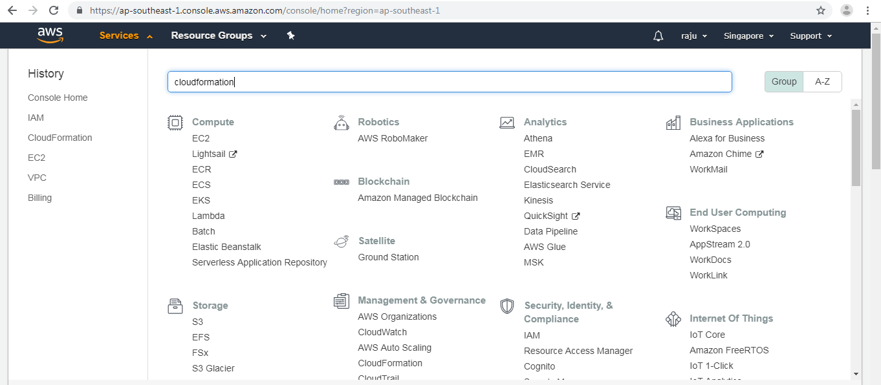

Select create new stack option:

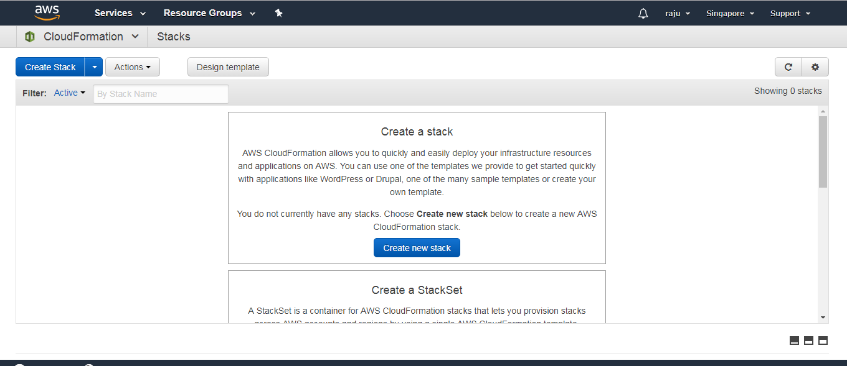

Under this select upload a template using amazon s3. and upload the cft.yaml file:

and click on next

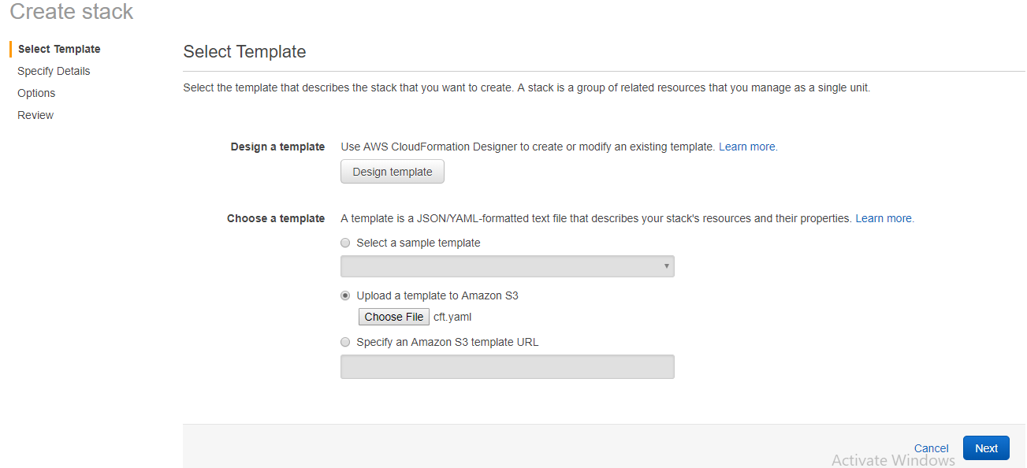

Here give your stack name and key file name:

my values:

stack name webserver

key file: cft

SSHLocation: 131.247.0.0/16

then click next

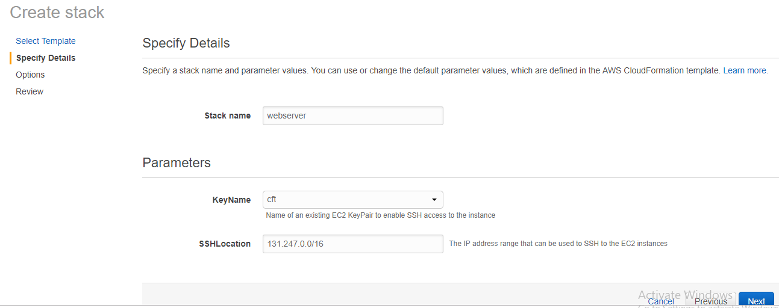

Here you can give tags, rollback monitoring time..

Otherwise click on next

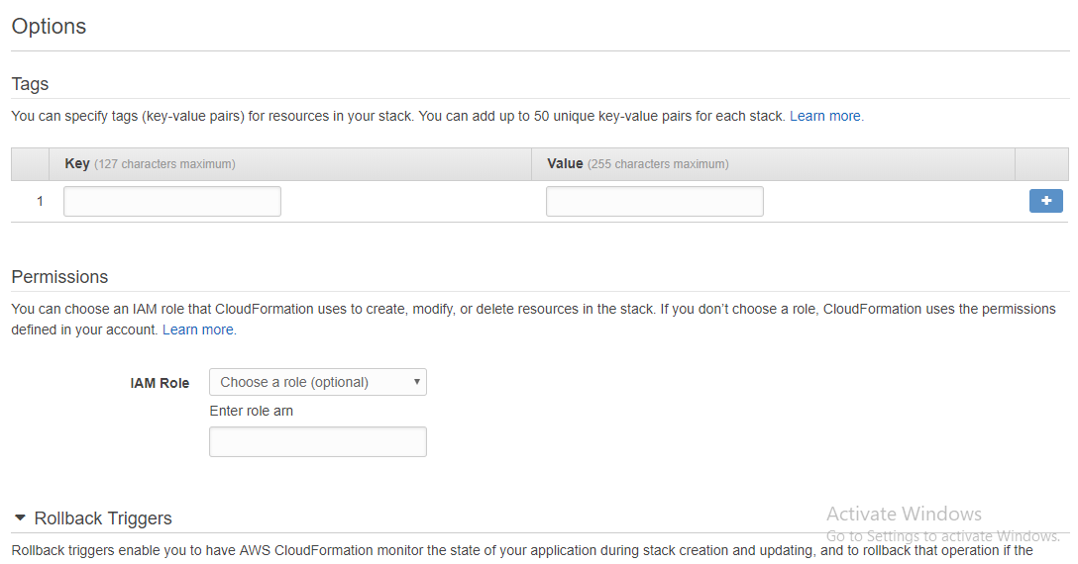

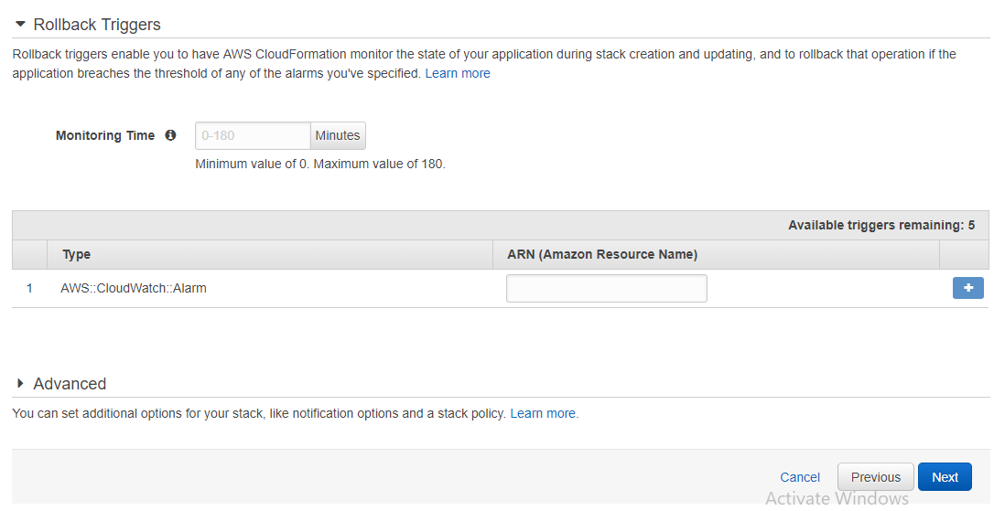

Review the templates and click on create

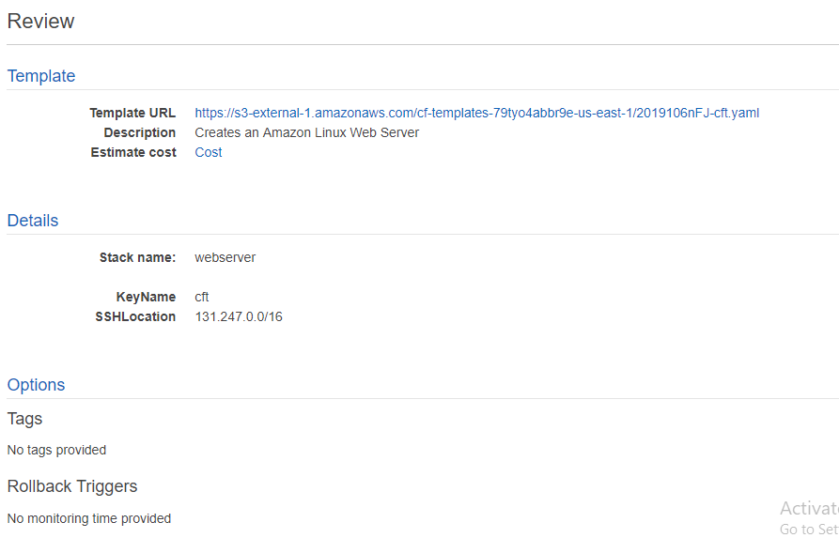

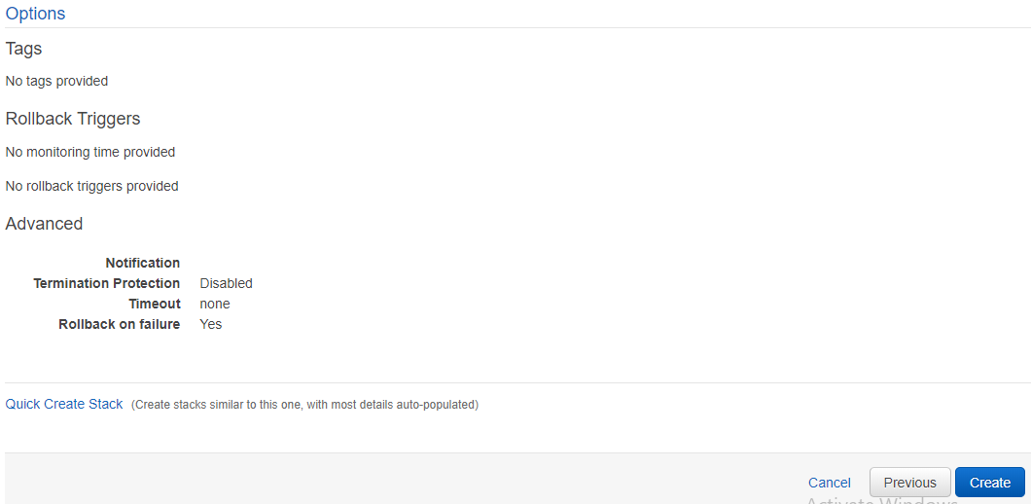

**Stack creation of Webserver is completed**

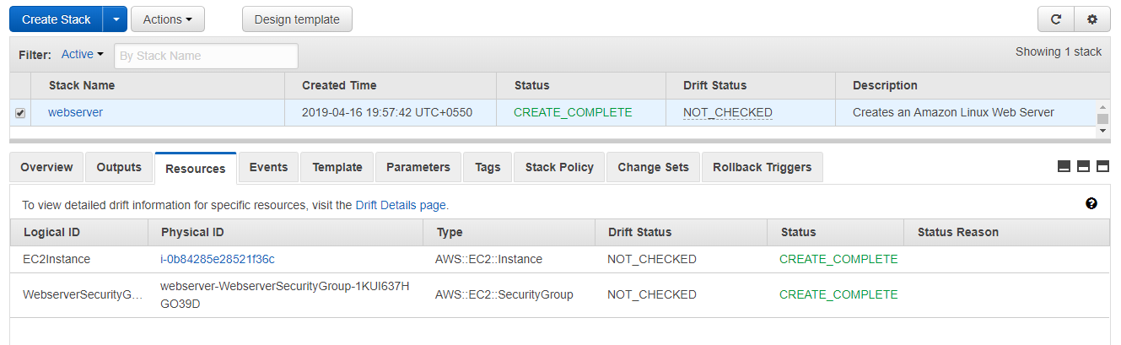

**using the**

1)cloudFormation

2)AWS EC2

3)AWS EBS

4)AWS S3

5)AWS DEFAULT VPC

just check events to know the created resources in AWS.

For checking the webserver is ping or not:

Using the Pinging tool to know

<https://www.site24x7.com/ping-test.html>

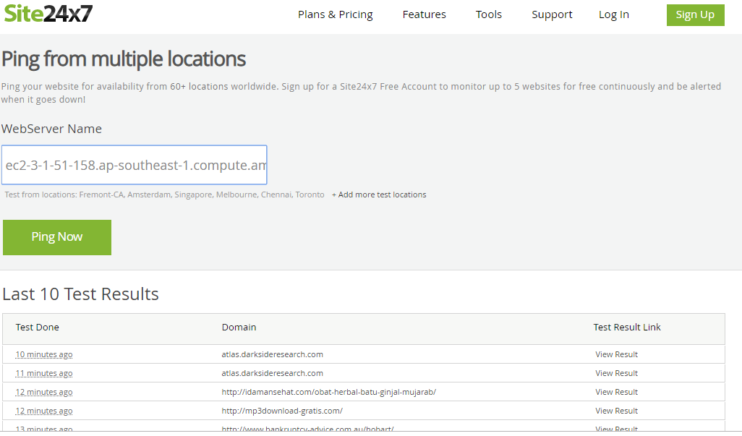

and paste your Public DNS of webserver instance and click on Ping now you can find the DNS on outputs section of stack

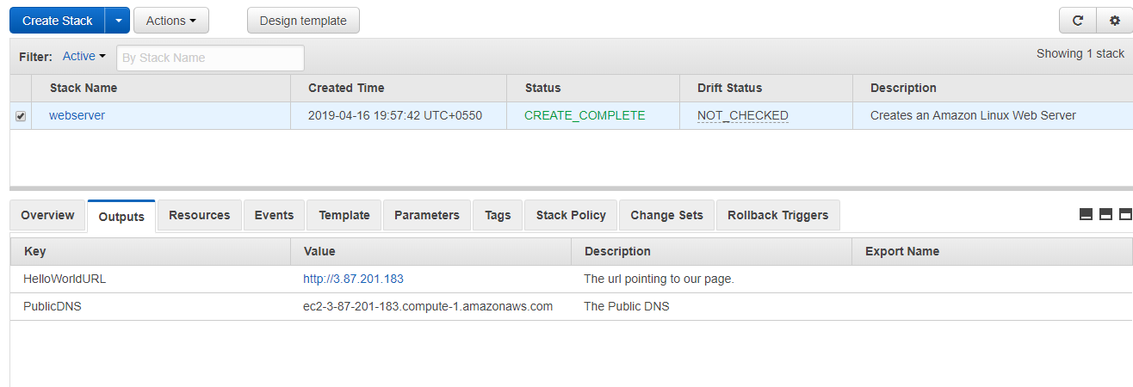

The following are the test results

